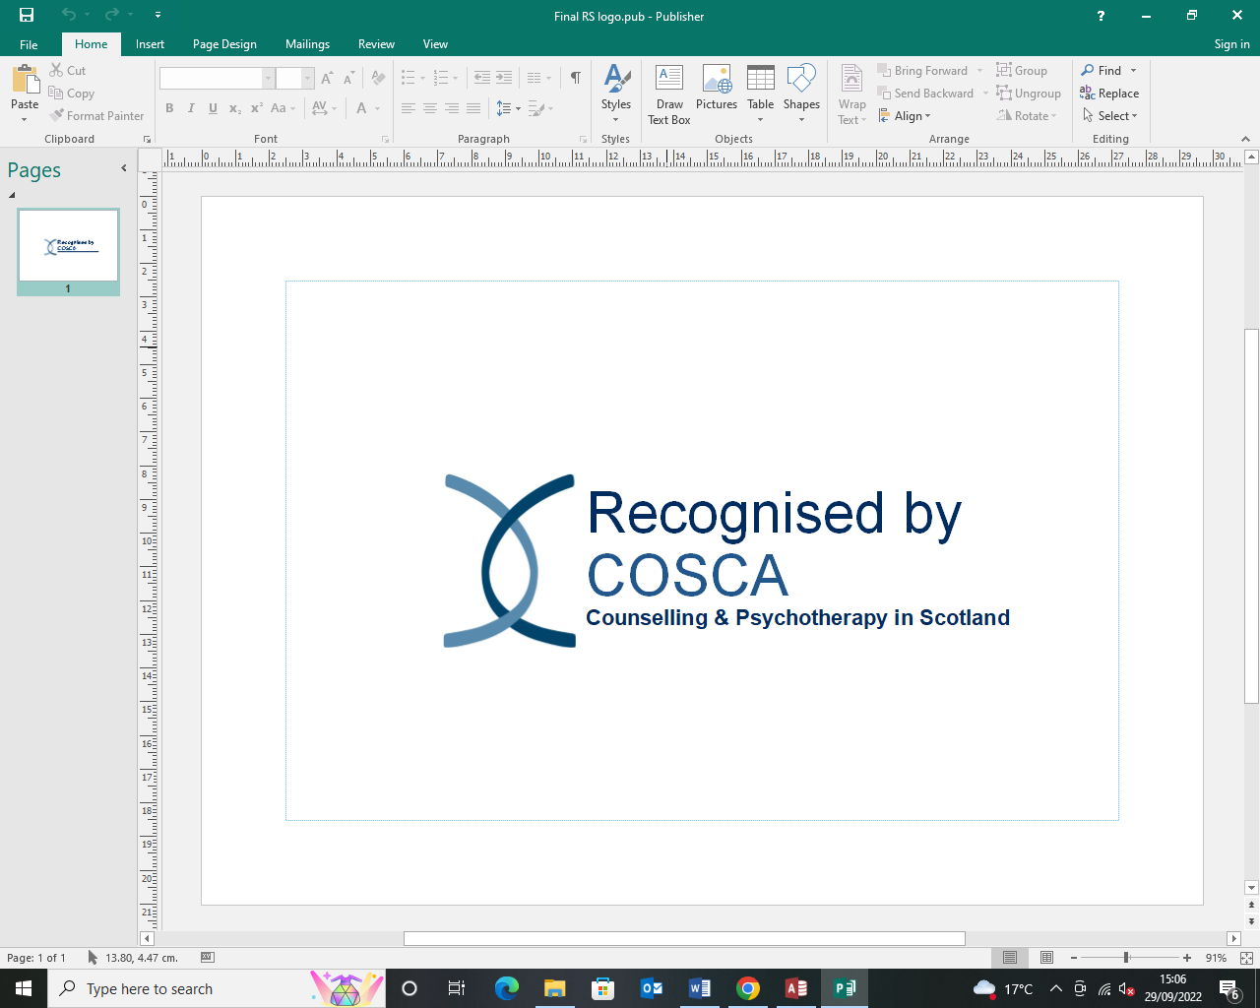
COSCA (Counselling & Psychotherapy in Scotland)
16 Melville Terrace | Stirling | FK8 2NE
t: 01786 475 140 f: 01786 446 207
e: info@cosca.org.uk w: www.cosca.org.uk
Charity Registered in Scotland S018887
Charitable Company Limited by Guarantee Registered in Scotland No. 142360

RECOGNITION SCHEME FOR ORGANISATIONS

REGISTRATION FORM

ABOUT YOUR ORGANISATION

NAME OF ORGANISATION:…………………………………………………………………………………….
ADDRESS:…………………………………………………………………………………………………………….
……………………………………………………………………………………………………………………………
POSTCODE:…………………………… TELEPHONE:……………………….……………………………….

CONTACT PERSON:……………………………………………………………………………………………….
POSITION:……………………………………………………………………………………………………………
DIRECT LINE TELEPHONE NUMBER:……………………………………………………………………….
EMAIL:…………………………………………………………………………………………………………………
DETAILS OF WHEN BEST TO CONTACT YOU:…………………………….………………….
…………………………………………………………………………………………………….

To be eligible for entrance into the Recognition Scheme, organisations must be current organisational members of COSCA

Are you a current member of COSCA: Yes □ No □
Membership Number:…………………………………………………

If you are not a member and wish to enter the Recognition Scheme, please download and complete a membership form from www.cosca.org.uk

Please tick which best describes your work: (see Information, Guidance and Procedure document)

Counselling/Psychotherapy Organisation □ | Counselling Skills Organisation □

Summary of what your organisation offers:

Supporting Statement

……………………………………………………………………………………………………….
wish to register for the COSCA Recognition Scheme and agree to:
- gather all the evidence required to support our application for Recognition, submitting the Evidencing Outcomes and Assessing Impact Report Form within 9 months of Registration
(if not submitted within this time, Registration will be withdrawn and the fee forfeited)
- pay the £100 Registration fee
- pay the subsequent £100 assessment fee that will be required should we proceed with assessment
- become a COSCA organisational member (if you are not one already)
- renew organisational membership annually

Signed:……………………………………
Name:…………………………………….
Position:…………………………………..
Date:……………………………………….

In order to register for the Recognition Scheme, this form should be completed, signed and returned to the Recognition Scheme Development Officer at COSCA with the £100 registration fee (payable to COSCA)

