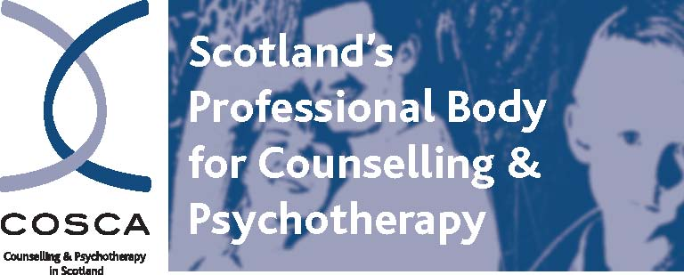
COSCA (Counselling & Psychotherapy in Scotland)
16 Melville Terrace | Stirling | FK8 2NE
t 01786 475 140 f: 01786 446 207
e: info@cosca.org.uk w: www.cosca.org.uk

ADVERTISING WITH COSCA (Counselling & Psychotherapy in Scotland)

- Advertisements are accepted at the discretion of COSCA and within the limitations of our capacity to deal with these requests
- COSCA can accept adverts and other information that it considers to be of high value and of interest to its members and the public
- Advertising must be in the interests of COSCA
- COSCA reserves the right to request editing of advertisements
- COSCA advertises only COSCA validated training programmes and can accept adverts from other organisations for Continuing Professional Development (CPD) courses and other events.
- Advertising can be accepted from COSCA Members and non-members. An Individual Member of COSCA who works for a non organisational member of COSCA for whom the advertising relates will be charged at the Non Members rate
- COSCA does not endorse or accept responsibility for the content of the information supplied in advertising
- All advertising material requires to be in pdf format
- COSCA accepts one pdf document per advertiser
- Please refer to the section under Finance on this document for payment requirements
- Please contact danielle@cosca.org.uk – or at the above address/telephone number, if you wish to advertise through COSCA

Ways of advertising with COSCA:

1. On the COSCA Website: www.cosca.org.uk

- Events - Other
- Vacancies - Other

Cost to Members: Free of Charge
Cost to Non Members: £25.00

One pdf document per advertisement (up to 20 MB)
Advertisements will be removed from the website when the material becomes out of date but within a three three-month period.

2. With COSCA E-Shots and Information Updates to COSCA Members:

Cost to Members: £95.00
Cost to Non Members: £105.00

This service aims to publish advertisements as soon as possible following receipt.

One pdf document per advertisement (up to 20 MB) can be submitted.

COSCA reserves the right to change the date of issuing an E-Shot/Information Update.

3. The COSCA Journal Counselling in Scotland:
Members Non Members

- ¼ page advert in Journal £50 £60
½ page advert in Journal £80 £100

Please refer to www.cosca.org.uk – Journal – Submission Guidelines and Deadlines for information on how to present advertisments for inclusion in the COSCA Journal.

Online copies of the COSCA Journal – Counselling in Scotland can be purchased: £7.50

4. Finance:

VAT Zero rated
- Advance payment is required - at least one week prior to advertisement going live
- COSCA reserves the right to omit from display/circulation any advertisement for which payment has not been received

Payment may be made by BACS or by cheque
Telephone banking is not available

BACS:
Bank: Virgin Money, Murray Place, Stirling FK8 2BX
Sort Code: 82 68 05
Account No: 70174110
Account Name: COSCA (Counselling & Psychotherapy in Scotland)

Cheque:
Made payable to COSCA (Counselling & Psychotherapy in Scotland)

There is a £2.00 charge if an invoice is requested. If an invoice is required, please provide the name and address for processing.

