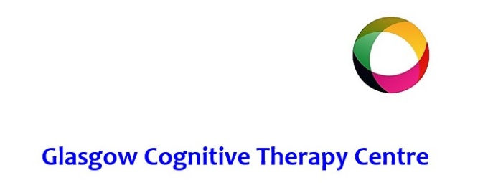

**COSCA Counselling Supervision Certificate**

The course is aimed at counselling practitioners or counselling skills users . Participants must have at least two years experience as a counsellor. COSCA have designed this course to have two exit award levels.

**1. Certificate in Counselling Supervision Skills – 10 SCQF credits at level 9**

This is designed for those who complete the 12 Units and submit one written assignment. (The transcript and analysis)

 Such individuals are probably not acting as supervisors and trained to less than Diploma Level.

**2**. **Certificate in Counselling Supervision – 15 SCQF credits at level 9**

This is designed for those who complete the 12 Units and the transcript assignment and who also, in addition,

complete a minimum of 12 hours as a supervisor with not less than two supervisees and not more than four.

**Course content**

The course covers essential theory eg. models of supervision:, and theoretical concepts such as parallel processing, ethics. It also provides participants with an opportunity to practice skills . There is also an emphasis on personal growth and personal reflection.

**Assessment**

A transcript of 10 mins session with analysis and a 2-3000 word case study.

**Course fees:**

The cost of the entire programme is £800 (incl. VAT). Fees can be repaid by a pre-agreed payment plan if required.

**Attendance requirement:**

The **minimum** attendance is 11 out of 12 units to be considered for certification. Please note that Units 11 and 12 **MUST** be attended by those wishing to complete the Certificate in Counselling Supervision.

***Wednesdays (0930-1630) starting 4th September 2024.***

**How to proceed:**

If you would like to apply for a place on this programme or require more information, then please email [admin@glasgowcognitivetherapycentre.com](mailto:admin@glasgowcognitivetherapycentre.com) for an application.