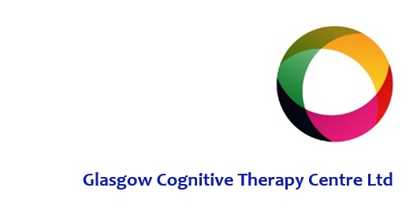

Rothesay House

134 Douglas Street

Glasgow

G2 4HF

0141 332 0229

[www.glasgowcognitivetherapycentre.com](http://www.glasgowcognitivetherapycentre.com)

COSCA Counselling Supervision Certificate Course

Teaching timetable

Course start date: Wednesday 4th September 2024



|  |  |
| --- | --- |
| **Glasgow Cognitive Therapy Centre**  **COSCA Counselling Supervision Certificate – Daytime Class**  **Wednesday 9.30-4.30** | |
| **Sessions** |  |
| Unit 1 - Introductions | 4th September 2024 |
| Unit 2 – Structure and Skills |  |
| Unit 3 – Models of Supervision: 1 | 11th September 2024 |
| Unit 4 – Models of Supervision: 2 |  |
| Unit 5 – Hidden Communications: Transference and Countertransference in Supervision and in Therapy | 18th September 2024 |
| Unit 6 – Hidden Communications: Countertransference Continued; The Parallel Process and Projective Identification |  |
| Unit 7 – Understanding Ethics | 25th September 2024 |
| Unit 8 – Ethical Decision Making |  |
| Unit 9 – Contracts Between Counsellor and Supervisor | 2nd October 2024 |
| Unit 10 – Creative Approaches to Supervision |  |
| Unit 11 – Evaluation: Integrated Practice with Audiotape | 16th October 2024 |
| Unit 12 – Evaluation: Feedback and Completion of the Course |  |