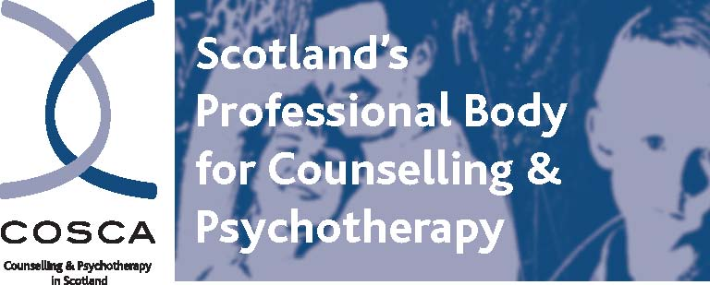

COSCA (Counselling & Psychotherapy in Scotland)
16 Melville Terrace | Stirling | FK8 2NE
t: 01786 475 140
e: info@cosca.org.uk w: www.cosca.org.uk

Lay Representative on COSCA’s Board (Voluntary Position)

COSCA (Counselling & Psychotherapy in Scotland) wishes to co-opt two members of the public as Lay Representatives onto its Board of trustees.

As Scotland’s professional body for counselling and psychotherapy, we seek to advance and support all forms of counselling, psychotherapy and the use of counselling skills.

We are looking for two members of the public on a voluntary basis who have a broad interest in counselling and psychotherapy, are not a counsellor or psychotherapist and not a member of COSCA, and who will help to provide strategic leadership for COSCA. Good team working is important for these important and interesting appointments.

The successful applicants will be co-opted initially for a period of one year, renewable up to a maximum of 3 years. They will be required to attend quarterly meetings of the Board, usually on Monday mornings in person in Stirling or online. A Lay Representative can speak at Board meetings but is not allowed to vote or be counted in the quorum needed for Board meetings. Induction support will be provided. Previously agreed travel expenses can be claimed for attendance at Board meetings.

For full details on how to apply, please see below or under vacancies/COSCA on our website. www.cosca.org.uk. To discuss your interest, please contact Brian Magee, Chief Executive. brian@cosca.org.uk

The closing date for applications is noon on Monday 2nd June 2025.

COSCA (Counselling & Psychotherapy in Scotland)
16 Melville Terrace | Stirling | FK8 2NE
t: 01786 475 140
e: info@cosca.org.uk w: www.cosca.org.uk

Lay Representatives Application Briefing Pack

Introduction

Thank you for your interest in being co-opted as a Lay Representative onto the Board of COSCA (Counselling & Psychotherapy in Scotland). This briefing pack sets out the information relating to the co-option of Lay Representatives. After reading the information, we hope that you will decide to apply to apply to become a Lay Representative.

Why Become a Lay Representative?

Becoming a Lay Representative provides you with the opportunity to become involved and play an active role in the work of Scotland’s professional body for counselling and psychotherapy. This appointment is a way for you to contribute to the advancement and development of counselling and psychotherapy in Scotland, improve your contacts, and use and develop your skills and experience.

The Board

COSCA’s Board currently consists of 11 individuals, most of whom are elected by the membership of COSCA to represent an area of interest linked to the implementation of COSCA’s Development Plan. The Board has four appointed office bearers (Chair, Vice Chair, Treasurer and Company Secretary) and two co-opted Lay Representatives. As co-opted members of the Board, Lay Representatives are entitled to attend and speak at meetings of the Board, but are not entitled to vote thereat and are not counted in the quorum.

Duties and Responsibilities of the Board

The role of the Board is to:

- ensure that COSCA complies with all legislative and regulatory requirements
- ensure that COSCA uses its resources exclusively in pursuance of its charitable objectives
- give firm strategic direction to COSCA, setting overall policy, defining goals and evaluating performance
- safeguard COSCA’s reputation and values
- ensure the effective and efficient governance of COSCA
- ensure the financial stability of COSCA
- protect and manage the property of COSCA, and to ensure the proper investment of COSCA’s funds
- employ COSCA staff.

In addition to the above, members of the Board are expected to use their skills, knowledge and experience to help the Board to reach sound decisions.

Lay Representative Person Specification

All applicants must have a demonstrable commitment to COSCA’s objectives. In addition, all applicants must be able to demonstrate the following skills:

- ability to think strategically and creatively
- ability to discharge the core responsibilities of being a charity director/trustee
- willingness and ability to commit the time to Board meetings
- willingness and ability to be effective ambassadors for COSCA.

In addition, applicants must be able to demonstrate skills, knowledge and experience in at least one of the following:

- financial management/accountancy
- income generation
- human resources expertise
- experience as a teacher, nurse, doctor, social worker, lawyer, banker or a professional role other than that of a counsellor or psychotherapist
- experience as a Board Member or Trustee
- experience in marketing
- relevant media experience.

Time Commitment and Nature of Involvement

The term of appointment is initially one year, with the possibility of renewal at the end of each year, up to a maximum of three years. Lay Representatives will be co-opted by the Board to become members of it and attend its quarterly meetings. These meetings usually take place in person in Stirling or online on Monday mornings, and are two hours in length. In addition, Lay Representatives may be given opportunities to become involved in other ways in the work of COSCA e.g. attendance at COSCA events, membership of working groups etc. Any reasonable and previously agreed expenses whilst fulfilling the duties of a Lay Representative will be reimbursed.

Eligibility

Under section 69 of the Charities and Trustee Investment (Scotland) Act 2005, individuals are disqualified from becoming charity board members if they:

- are under 18 years of age
- have an unspent conviction for dishonesty or an offence under the above Act
- are undischarged bankrupt
- have been removed under either Scottish or English Law or the courts from being a charity trustee
- are disqualified from being a company director.

Conflicts of Interest

Lay Representatives will be required to declare in their application any conflicts of interest and, if appointed, work within the COSCA Conflict of Interest Policy.

Application Process

You are invited to apply to become a Lay Representative by completing and signing the application form included in this Information Pack. Please return your completed application form by email to:

brian@cosca.org.uk

All applications will be acknowledged on receipt. Applicants will be assessed against the above Lay Representative Person Specification criteria. Successful applicants will be invited to attend an interview conducted by a panel that will include the Chair and Chief Executive of COSCA (Counselling & Psychotherapy in Scotland).

Further Information

Please contact Brian Magee, Chief Executive, if you would like to discuss your interest in becoming a Lay Representative. brian@cosca.org.uk

Further information on the work of COSCA (Counselling & Psychotherapy in Scotland) can be found on our website. www.cosca.org.uk

Further information on the role and responsibilities of charity trustees can be found on the website of the Office of the Scottish Charity Regulator. www.oscr.org.uk

Brian Magee
Chief Executive
COSCA (Counselling & Psychotherapy in Scotland)

April 2025

