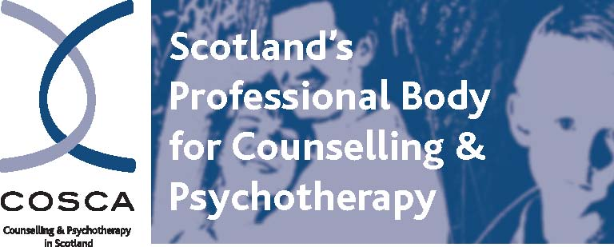
COSCA (Counselling & Psychotherapy in Scotland)
16 Melville Terrace | Stirling | FK8 2NE
t 01786 475 140 f: 01786 446 207
e: christina@cosca.org.uk w: www.cosca.org.uk

ADVERTISING WITH COSCA

- Advertisements are accepted at the discretion of COSCA and within the limitations of our capacity to deal with these requests
- COSCA can accept adverts and other information that it considers to be of high value and of interest to its members and the public
- Advertising must be in the interests of COSCA
- COSCA reserves the right to request editing of advertisements
- COSCA advertises only COSCA validated training programmes and can accept adverts from other organisations for CPD courses and other events.
- Advertising can be accepted from COSCA Members and non-members. An Individual Member of COSCA who works for a non organisational member of COSCA for whom the advertising relates will be charged at the Non Members rate
- COSCA does not endorse or accept responsibility for the content of the information supplied in advertising
- All advertising material requires to be in pdf format
- COSCA accepts one pdf document per advertiser
- Please refer to the section under Finance on this document for payment requirements
- Please contact Christina Oliver, COSCA Administrator – christina@cosca.org.uk – or at the above address/telephone number, if you wish to advertise through COSCA

Ways of advertising with COSCA:

1. On the COSCA Website: www.cosca.org.uk

- Events - Other
- Vacancies - Other

Cost to Members: Free of Charge
Cost to Non Members: £25.00

One pdf document per advertisement (up to 1MB)
Advertisements will be removed from the website when the material becomes out of date but within a three three-month period.

2. With the E-Bulletin/Information Update to COSCA Members:

Cost to Members: £95.00
Cost to Non Members: £105.00

This service is normally available at the beginning of a month.

One pdf document per advertisement (up to 1MB)

COSCA reserves the right to change the date of processing an E-Bulletin/Information Update

3. The COSCA Journal Counselling in Scotland:

Members Non Members

- Cost of flyer insert with the COSCA Journal: £95 £105
(1 x A4 or 1 x A5 flier)
COSCA does not photocopy publicity material for circulation with the Journal.

- ¼ page advert in Journal £35 £45
½ page advert in Journal £50 £60

Please refer to www.cosca.org.uk – Journal – Submission Guidelines and Deadlines for information on how to present articles for inclusion in the COSCA Journal.

The COSCA Journal – Counselling in Scotland – is available to be purchased: £7.50 including p&p.

FINANCE:

VAT Zero rated
- Advance payment is required - at least one week prior to advertisement going live
- COSCA reserves the right to omit from display/circulation any advertisement for which payment has not been received

Payment may be made by BACS or by cheque
Telephone banking is not available

BACS:
Bank: Clydesdale Bank PLC
Sort Code: 82 68 05
Account No: 70174110
Account Name: COSCA (Counselling & Psychotherapy in Scotland)

Cheque:
Made payable to COSCA (Counselling & Psychotherapy in Scotland)

There is a £2.00 charge if an invoice is requested. If an invoice is required, please provide the name and address for processing.

