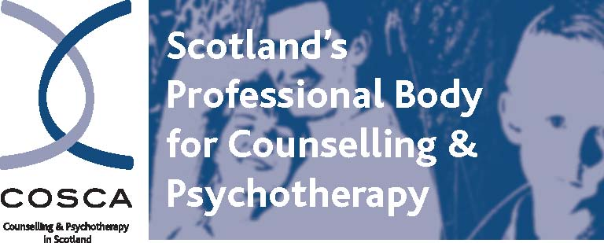
COSCA (Counselling & Psychotherapy in Scotland)
16 Melville Terrace | Stirling | FK8 2NE
t: 01786 475 140 f: 01786 446 207

e: rozanne@cosca.org.uk w: www.cosca.org.uk

COSCA REGISTRATION OF PARTICIPANTS
FOR USE BY ALL COSCA VALIDATED COURSE PROVIDERS

This form is a request for the registration and issuing of certificates for participants on COSCA Validated Courses.
Please submit the form at the end of each Module.

- Cost per participant per registration: £3.50 (Per Module/Block/Diploma)
- Cost per Certificate issued by COSCA: £10.00
- Participants who have Unsuccessfully Completed should also be registered. There is no charge for this registration.
- An invoice will be sent upon receipt of this form
- A charge of £10.00 will be made for duplicate Certificates where a spelling error has been made on this form.
- Please indicate if APL/APEL has been given.
- Successful participants need to have met all the learning outcomes and the attendance requirements of the course
- If the course has been awarded a SCQF level and credits, it needs to be delivered accordingly
- As per COSCA Validation Guidelines, COSCA allows 8 weeks from receipt of the form to register/issue certificates. This timescale is normally only in exceptional circumstances.
- If an electronic handbook was issued to the participant there will be a charge of £10 license fee per student per module for this or £20 license for the COSCA Counselling Supervision course.

Name and Address of Validated Training Provider:

Email address of contact person:

Name of contact person:

Course Type | Title of Course to be Registered
COSCA Counselling Skills Certificate
Other Counselling Skills Certificate
COSCA Counselling Supervision
COSCA Counselling Supervision Skills
Other Counselling Supervision Course
COSCA Further Steps in Counselling Skills
COSCA Group Counselling Skills
Diploma
Specialist

Date of Commencement of Module/Course  (Please indicate date of commencement of each Module if relevant) | Date of Completion of Module/Course  (Please indicate date of completion of each Module if relevant) | If the Course is Modular, please enter the Module to be Registered  i.e. Module 1, 2, 3 or 4 | Certificate to be Issued  Yes No

Surname of Participant | First Name of Participant | Date of Birth | Current Address | Successfully  Completed.  Please √  APL/APEL given (please indicate) | Unsuccessful  Please √ | Attendance Requirements met  Please √ | PDF handbook issued? (£10 license fee applies per module, or £20 for the Supervision course)  Please √ | If hard copy of handbook was issued what date did you send the order to COSCA? | Participant workplace  i.e. social  work, health,  education

DECLARATION: I declare that all the above successful students have been assessed and have met all the Learning Outcomes and attendance requirements as outlined in this COSCA Validated Course.

Signature | Please print name | Designation within Organisation
Date

